Our mission is to…

…provide staff and families a safe, diverse childcare environment dedicated to respectful communication, problem solving, creative learning and the freedom to play!
About our program

Blazing Trails, located at Pathfinder K - 8 in West Seattle, is a non-profit before and after school childcare program for school-age children ages five through twelve. We also offer summer enrichment programs.
Blazing Trails’ CoRs

Children of different ages are organized into Communities of Respect (CoRs). For the summer, DUCKS are children entering kindergarteners, RACCOONS are children entering 1st-2nd grade and BADGERS, entering 3rd grade and up. Incoming middle schoolers who are interested may apply to join the LYNX CoR (See Mckinsey for more information on the application process). CoR assignments may shift when school starts. Although we are housed at Pathfinder K-8, our summer program welcomes students who will attend other schools in the fall. *Due to staffing, Lynx and Badgers will do projects together.

Blazing Trails’ Philosophy and Vision

Our vision: “Children are empowered to discover their worth.”

We are dedicated to supporting families in our community as we help each child develop good communication skills and celebrate his or her own uniqueness. We maintain an environment that encourages intellectual, physical and social growth with respect for others and the natural environment. People relate to each other peacefully and we joyfully appreciate our rich diversity.

Staff training is a crucial component to accomplishing our goals. We support our staff, both professionally and personally, through respect for each other’s personal differences and unique teaching styles. We provide opportunities for shared leadership, professional growth and development and an environment that encourages mutual support and care.

Blazing Trails Childcare

Inclusion Policy

Our Statement of Anti-discrimination,

Anti-bias & Cultural Sensitivity

We foster an understanding of diversity among people, expecting and modeling unconditional respect for self and others. We enjoy celebrating and exploring our community’s rich cultural diversity.

All children and their families are accepted according to our policies without regard to race, color, religion or belief structure, creed, ancestry, gender or gender identity, sexual orientation, national origin or the presence of any sensory, mental or physical challenges. We have no religious affiliation.

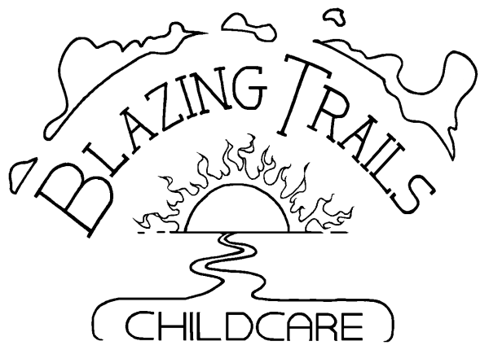

presents

OUR
SUMMER
PROGRAM

Raccoon☺Badger☺Lynx
July 5 – August 18, 2023

Pathfinder K-8 School
1901 SW. Genesee Street
Seattle, WA 98106

Rita Garton – Director
Office Phone: 206-937-5160
Rita’s Cell: 206-459-4976

Check us out at … www.blazingtrails.org

Blazing Trails Childcare
Information

- We are open from 6:30 AM to 6:00 PM. during the 7 weeks of the 2023 summer program.
- Blazing Trails is a non-profit organization with its own governing board.
- Blazing Trails maintains, on average, at least an 11 to 1 student/teacher ratio, varying with different activity types; i.e. more kids per teacher with gym/playground activities and less with directed projects. No group is ever larger than 15:1.
- We have use of Pathfinder’s playground, playfields, playcourt, cafeteria and gym facilities.
- We provide healthy snacks and include many organic and home-cooked options. Check with Molly for more info.
- Blazing Trails accepts DSHS and City subsidies and has some scholarships available (limited) at the Director’s discretion.
- Drop-in days are $65.00 each and subject to availability.
- State law mandates that school-age children be in childcare a maximum of 10 hours/day.

OUR FIVE CORE VALUES

RESPECT means following the Golden Rule* by treating yourself and others with value and respect.

RESPONSIBILITY means accepting accountability for your actions and your role in the community.

HONESTY means being trustworthy and truthful.

CARING means considering the needs and feelings of others along with your own.

FUN means experiencing joy and including play as an integral part of life.

* THE GOLDEN RULE – Always treat others as you expect others to treat you.

Summer Tuition per Week

1 day/wk | 2 days/wk | 3 days/wk | 4 days/wk | 5 days/wk
$65.00 | $121.00 | $165.00 | $205.00 | $240.00

2023 Summer Schedule

Basic Daily Schedule

6:30 – 9:15 Quiet Choices, Movement
6:30-7:30 Breakfast
8:15-9:15 Gym game, Building area (#’s allowing)
9:15 – 10:15 Morning Snack & Morning Movement
10:15 – 11:00 Game Time, Gym
11:00 - 12:00 Teacher Led Project, Gym, Building area, Quiet Choices
12:00-1:00 Hand washing, Lunch and Recess
1:00 – 1:55 Eyes and Ears on a Book
2:00 – 3:00 Teacher Led Project, Water Play, Building area, Quiet Choices
3:00 – 3:45 Snack & Recess
3:45 – 4:30 Rest & Recharge
4:30 – 5:30 Gym, Building area, Open Classroom
5:30-- 6:00 Quiet Choices & Clean Up

SUMMER CURRICULUM

In summer, teacher-led projects (above) are one of many choices available. Choices are designed to encourage creativity & exploration, develop skills, apply core subjects practically to everyday tasks and to have fun! Other choices include: self-directed open den options, games with Jackson and more! See the Summer 2023 Schedule for more curriculum details.

Movement games with Jackson use various approaches designed to build skills and expand understanding of rule concepts and applications. For example: when the calendar says “Basketball”, it means they will “explore” basketball. They might play HORSE, bump or 21. They might practice some basketball skill building exercise or create their own rules. See Jackson’s Summer Schedule for more information.

LYNX CoR: The Lynx CoR is designed for incoming middle school students who have displayed competence with self-direction, mentoring, problem solving and leadership. Curriculum is student designed and includes student selected science explorations, art, community involvement and other special adventures. Inclusion is by permission only – See LYNX Schedule and Mckinsey for more information.

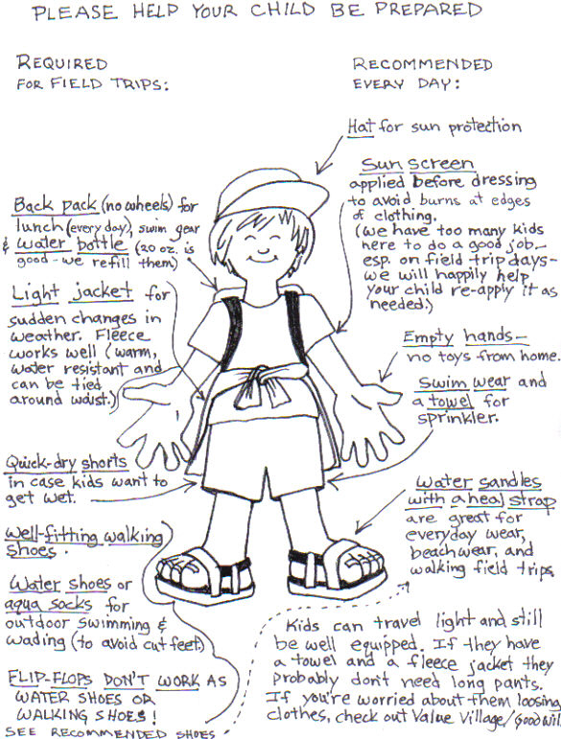
FIELDTRIP INFO: Until further notice, Blazing Trails will not be offering summer field trips. Instead, we will be taking walking trips around our neighborhood, inviting guest speakers and special activities. This will limit their time in a confined space (busses can be quite packed!) or opportunities where they will be mask free (it’s not easy to swim with a mask on…).

NOTE: Any students new to Blazing Trails are required to schedule at least one full day remaining at the Blazing Trails’ site before he/she attends a walking fieldtrip. It’s important that your child get to know our teachers and become familiar with our ways. It is equally important for our staff to learn about your child. This policy is for your child’s comfort and safety.

